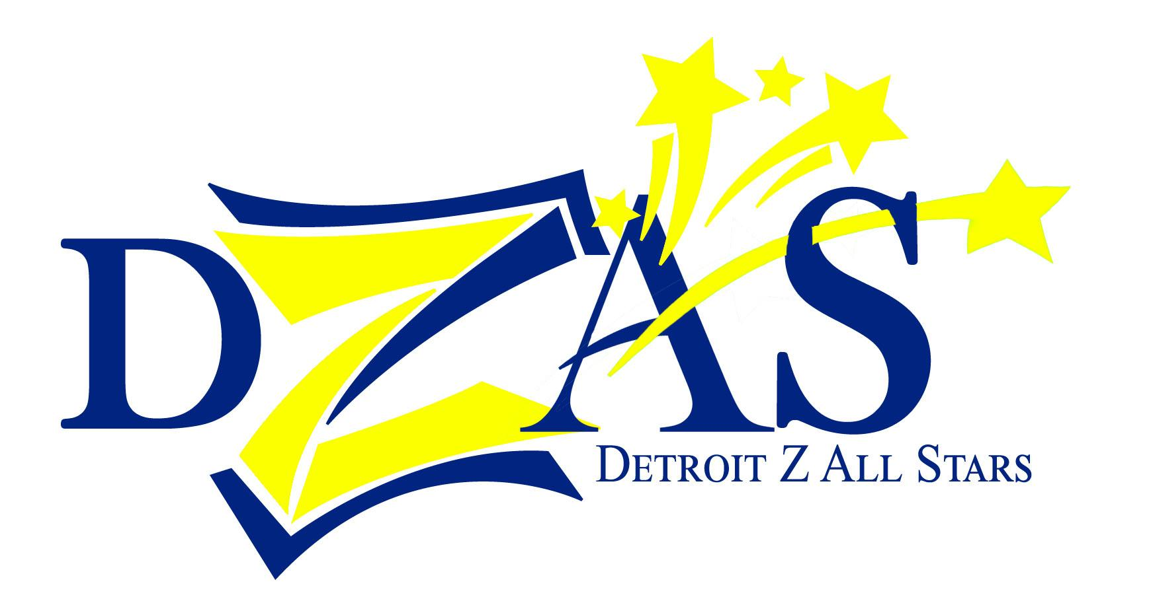 | Zumba® Fitness Party with the  Detroit Z All Stars!

VENDOR AND SPONSOR INFORMATION

Event Date:  Friday, October 17, 2014 at 5:30pm  Bert’s Entertainment Warehouse  2727 Russell Street, Detroit MI 48207  Event Timeline:  4pm-5:30pm Vendor arrival/setup  5:30pm-7pm Doors open for shopping  7pm-8:30pm Zumba® party  8:30pm-9:30pm Shopping  9:30pm-10pm Breakdown  Vendor/Sponsor Pricing:  - Sept 1-Sept 10: $35  - Sept 11-Sept 30: $50  - Oct 1-Oct 14: $75  - Nonprofits: free  - Sponsorships: up to $250 | Contact:  Chandra Floyd  313.587.6203  ZumbaWithChandra@yahoo.com  Individual tickets - $10:  http://dzasberts2014.eventbrite.com  DZAS website:  www.dzas.weebly.com  Facebook event page:  https://www.facebook.com/events/677274555699474/  Official Facebook page:  https://www.facebook.com/detroitzumbaallstars  Twitter:  @detroitzallstar

WHO

In October 2013 we had over 100 guests and 35 vendors. In May 2014, we had 225 guests and 60 vendors. Vendors and sponsors do not have to be health/fitness related.

WHO PART 2

This event is organized by four licensed Zumba® Fitness instructors who lead fitness classes in the city of Detroit: Chandra Floyd, Marius Padieu, Patti Dukes Jordan, and Letitia Wesley. We have deep roots in Detroit, and want to be part of the positive rebirth of the city.

WHAT

The goal of this event is to encourage health and wellness in the city of Detroit. There are few gyms and fitness facilities accessible to the general public within the city limits, and this event is designed to make fitness FUN and bring it to the community.

Detroit Zumba® All Stars
Vendors & Sponsors
Page 2

WHAT PART 2

Zumba® Fitness is a dance fitness cardio class that uses Latin and other international music to create a fun, bass thumpin’ heart poundin’ effective workout that can burn up to 1,000 calories an hour. For more details, visit Zumba.com.
WHEN/WHERE

See above.

WHY

This is the only event of its kind inside Detroit city limits! We need you to help us show people that fun and fitness are accessible AND affordable, and that there are many cool local businesses that need their support.

HOW

Send an email to ZumbaWithChandra@yahoo.com and a personalized registration link will be emailed to you. PLEASE NOTE that we are only accepting one or two vendors per category, and this is on a first come, first served basis. Your spot is only guaranteed upon paid registration.

To help keep ticket prices and vendor pricing low, we ask that you share the event on your Facebook and other social media networks or newsletters. Let your clients and friends know that they can find you at this event!

No vendors will be added after Tuesday, October 14th at 5pm. All vendors must be registered and paid by that date. Please bring no more than one or two assistants to help setup/run your table. Any additional helpers will need to register at www.dzasBerts2014.eventbrite.com and pay the $10 ticket fee.

DOOR PRIZES AND SOCIAL MEDIA

We will periodically list registered vendors on social media. Please feel free to also post a link to your site on the Facebook event! Please let us know if you would like to submit something to be used as a door prize (coupon, gift certificate, free sample, etc. No business cards or flyers). Door prizes should be clearly marked/tagged with the company name and description of the item.

Detroit Zumba® All Stars
Vendors & Sponsors
Page 3

LOAD IN

You are responsible for your own load in/load out. If you require tables, chairs, carts, etc, you will need to provide your own. Your designated spot is approximately 10'x10' wide. There are electrical outlets in the facility; however, you will need to provide your own extension cords if necessary. Ample self-parking is available adjacent to the building. All displays must be family friendly as children may be present at the event. PLEASE NOTE: this venue is at the Eastern Market, directly across from Shed 3.

WHAT’S IN IT FOR YOU

Benefits | $35-$75 Vendors | Bottled Water Sponsor | Snack Sponsor | $100  10-ticket sponsor | $250 Sponsor
Opportunity to submit a door prize | X | X | X | X | X
Your name/logo listed on the handout that will be distributed to every attendee | X | X | X | X | X
Prominent placement on the handout that will be distributed to every attendee |  | X | X | X | X
10’x10’ vendor area | X
A prominently placed 10’x10’vendor area with a sign identifying you as a sponsor |  | X | X | X | X
Announced as a Sponsor during the opening and closing announcements |  | X | X | X | X
Two event tickets to give away |  | X | X
Four event tickets to give away |  |  |  |  | X
Ten event tickets to give away |  |  |  | X
Your name/logo included in social media promotions |  |  |  |  | X
Your name/logo listed on the event ticketing page |  |  |  |  | X
Your name/logo listed on the press release (if sponsorship is paid before release goes out) |  |  |  |  | X

*Bottled water sponsor to provide 200 bottles of water (value of approx $75). Snack sponsor to provide 200 individually wrapped healthy snacks such as granola bars, baked chips, smoothies, popcorn, yogurt, etc. NO PEANUTS. (value of approximately $100). Product must be delivered by Wednesday, Oct 15. Arrangements can be made for pickup. For convenience, Sponsor can also choose to simply provide the funds and the event team will obtain the items needed.

